Mission Trip to Fayetteville, WV
July 10 – 16, 2021
Cost: $185
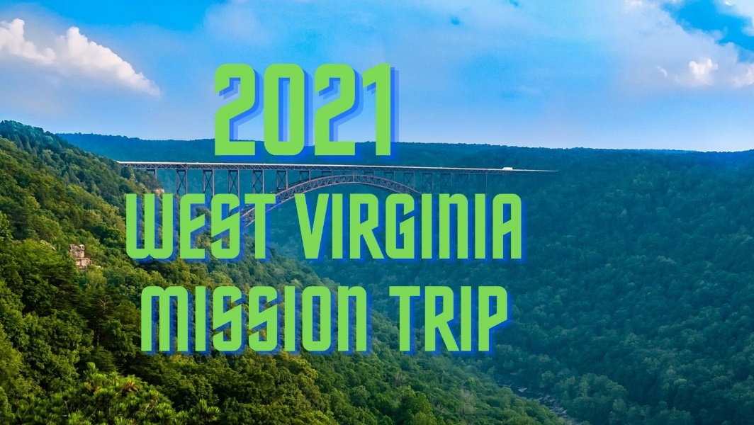

MINISTRIES
VBS, Block Parties, and Construction

PERSONAL INFORMATION

Name _________________________________________________ Date __________________

Address ______________________________________________________________________

City _________________________________________ State ________ Zip Code ___________

Telephone –Home (___) _____________ Work (___) ____________ Cell (___) _____________

Email Address__________________________________________________________________

Date of Birth ___________________ Church you attend________________________________

Interest Meeting: April 26th at 7:00 p.m. at CRBA
Training Date: May 24th at 7:00 p.m. at CRBA

Please sign me up for the West Virginia Mission Trip (signature)_________________________

Signature of parent (if participant is under age 18) _____________________________________

*Please return Registration form, Medical Release form,
and a non-returnable deposit of $100 by May 31, 2021.
Catawba River Baptist Association, 1812 US 70 E, Morganton, NC. 28655

